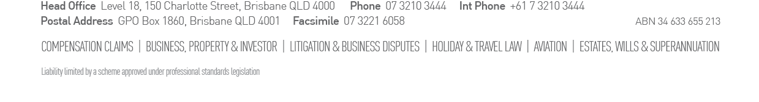
Our Ref: PC:KNM:P&O4851

Date: 1 March 2024

#INSERT

Also by email: ﻿#INSERT

Dear Group Member
RE: debrah jackson v carnival plc t/as p&o cruises australia
fEDERAL COURT PROCEEDING NO. QUD 183/2023

We are the solicitors for Debrah Jackson who is the representative applicant in a Class Action commenced on behalf of all persons who were passengers aboard the P&O ship Pacific Aria on its South Pacific voyage that departed Brisbane on 5 May 2017 and returned to Brisbane on 12 May 2017. The Class Action is titled Debrah Jackson v Carnival PLC t/as P&O Cruises Australia (QUD 183/2023) (P&O Class Action) and it is being conducted in the Federal Court of Australia in Brisbane. The P&O Class Action seeks compensation from P&O’s owner Carnival PLC.
You are receiving this Notice because - as one of the passengers – you are taken to a Group Member in the P&O Class Action
Attached is a Notice in relation to the P&O Class Action and your Group Member status issued in accordance with the recent order of Justice Derrington of the Federal Court of Australia.
Opt-Out
You are entitled to opt-out as Group Member of the P&O Class Action.
If you do not want to be a Group Member in the P&O Class Action; or do not want to claim against P&O; or for any reason do not want to be represented in the P&O Class Action you must complete the Opt Out form annexed to the enclosed the Notice and return it by 31 May 2024.
These matters are explained in the Notice. Please read the Notice carefully.
If you wish to remain a class member there is nothing you need to do. You are invited to contact us on 1300 529 529; or by email on P&Oclassaction@cartercapner.com.au; or by visiting https://cartercapner.com.au/travel-injuries/cruise-ship-injury-lawyers/and register as a class member so that future notices about the class action can be sent to your preferred address and we can obtain further details from you.
If you have questions, please contact Carter Capner Law on 07 3210 3444 or obtain your own legal advice.
Yours faithfully,
CARTER CAPNER LAW

Contact Person: Peter Carter
Direct Phone No: 07 3210 3417
Local Rate No: 1300 LAW LAW
Email: pcarter@cartercapner.com.au

